This series of power supplies incorporate the high frequency switch mode technology to give highly regulated chassis mountable modular units with kV range varying from 10kV to 50kV catering to a wide variety of scientific and industrial applications that include XRF instruments for elemental analysis, electro-spinning, hi-pot testing electrophoresis, cable testing, etc.
REGULATED HIGH VOLTAGE MODULE FOR XRF APPLICATION
10kV to 50kV, 1mA

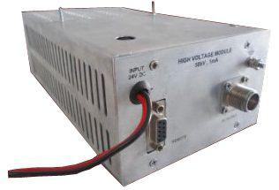
Features:
- Compact & Modular
- Precision Regulated
- High stability
- Remote operation

Technical Specifications
PARAMETER | SPECIFICATION
Input voltage | 24V DC ± 10%
Output Voltage* | 0 to 10/20/30/40/50kV DC
Output Current | 0 to 1mA
Polarity * | Positive / Negative
Line Regulation | <0.05% for±10% variation in input voltage
Load Regulation | <0.1% for 10 to 100%load variation
Stability | <0.01%hour after 1 hour warm up
Protections | Against overload, arc and short-circuit  During short circuit, internal circuitry limits the short circuit current
Front Panel | 24V DC input through 1.0sqm PVC wires  Fuse holder with fuse (on top plate)  RF connector for HV output  9 pin D-connector for remote control  Stud for grounding the unit
Size | 5” x 9” x 3” (W x D x H)
Weight | 2.5kg
Output cable | 26” of HV DC cable
- OEM Customization available
*Optional. To be specified by the user.
Remote Interface Connector Configuration
Pins | 28 Pin Pluggable Connector
1 | Common
2 | HV Enable (Active Low)
3 | Voltage Program
4 | Voltage Monitor
5 | Current Program
6 | Current Monitor
7 | Reserved
8 | Reserved
9 | +10V DC Reference
Ordering  Code | MF | 050 | K | 050 | W | P | C | 2 | D | 4 | L
 |  | 1 |  | 2 |  | 3
Section | Description |  |  | Options |  | Options Description
1 | Output Voltage |  |  | XX |  | Value of output voltage  XX=10/20/30/40/50:  For 10/20/30/40/50kV
2 | Output Power |  |  | YY |  | Value of output power (XX x 1mA)  YY=10/20/30/40/50W
3 | Polarity |  |  | P |  | Positive
 |  |  |  | N |  | Negative

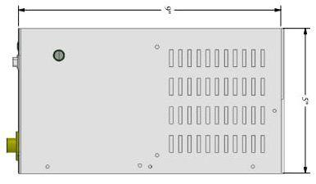

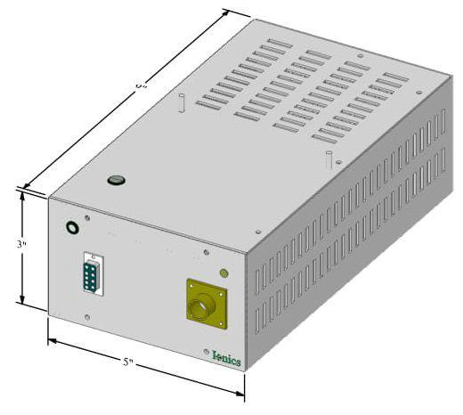

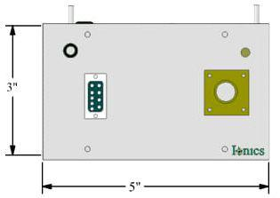

For any queries or customization requests contact us at info@ionics.co.in
For product line information visit us at www.ionics.co.in

